Cheshire East Safeguarding Children Partnership

TRAINING NEWSLETTER
Welcome to the CESCP training news.

Delivering a huge variety of inspirational learning opportunities to help boost your practice confidence, knowledge and skills.

**To justify running the multitude of FREE in-person events, we need you to book and ATTEND please!**
COURSES

November | Monday 9th  ¹⁰⁻¹ |  | Domestic Abuse Awareness |  | Online | Book a place here: Cheshire East Safeguarding Children's Partnership Training Events
November | Tuesday 10th |  | Safer Recruitment (for the wider children’s workforce, not including education) |  | In Person  Oakenclough | Book a place by emailing earlyyearsandchildcareteam@cheshireeast.gov.uk you will receive the teams link a couple of days before the training
November | Thursday  12th  6.30-8.30 |  | Basic Safeguarding Awareness |  | Online | Book a place by emailing earlyyearsandchildcareteam@cheshireeast.gov.uk you will receive the teams link a couple of days before the training
November | Thursday 26th  9.30-2 |  | LADO: Managing Allegations |  | In Person  Oakenclough | Book a place here: Cheshire East Safeguarding Children's Partnership Training Events
December | Weds 2nd  9.30-16.00 |  | Responding to Intra-familiar Child Sexual Abuse for the Multi-Agency Partnership |  | In Person  Oakenclough | Book a place here: Cheshire East Safeguarding Children's Partnership Training Events
December | Wednesday 9th  9.30-11.30 |  | Basic Safeguarding Awareness |  | Online | Book a place by emailing earlyyearsandchildcareteam@cheshireeast.gov.uk you will receive the teams link a couple of days before the training
January | Thursday 14th  9.30-1 |  | Responding to Sexual Assault and Violence  (Pan Cheshire Training) |  | Online | Places are limited. Please email:  cescptraining@cheshireeast.gov.uk to enquire about a space.
February | Wednesday 10th  9.30-2 |  | Digital Safeguarding |  | Online | Book a place here: Cheshire East Safeguarding Children's Partnership Training Events
February | Wednesday 10th  9.30-4 |  | Neglect Strategy: Tools and best practice |  | In Person  Oakenclough | Book a place here: Cheshire East Safeguarding Children's Partnership Training Events
*ON-LINE SHORT* sessions at mid-day: by automatic invite for your convenience
*NO BOOKING REQUIREMENT*
You will find further information on each topic embedded in your automatic invite
October |  | Thursday 22nd |  | LCSPR updates: Essential Partnership Learning for Professionals
 |  | Tuesday 27th |  | How to work with mental capacity legislation
November |  | Wednesday 11th |  | How to use the ERASE tool
 |  | - Tuesday 17th  - Wednesday 18th  - Tuesday 24th |  | Lunch and Learn – Voice of the Child and November Children’s Rights Month
 |  | Thursday 19th |  | LCSPR updates: Essential Partnership Learning for Professionals
December |  | Thursday 10th |  | How to use the ERASE tool
 |  | Thursday 17th |  | LCSPR updates: Essential Partnership Learning for Professionals

*REQUEST AN INVITE* – opportunities to join FREE training hosted by our partner organisations
Various | Monthly | Northwest Regional Organised Crime Unit: County Lines Training | ONLINE | For an invite contact: sarah.gannon@nwrocu.police.uk
Various | You choose when! | Anti-bullying alliance CPD training - this training is no longer free but is less than £30 per session. | ONLINE | For further information and to book, visit Anti-bullying CPD online training

Guest Events
Child to Adult Abuse. | WEBINAR | Course: Child to Adult Abuse webinars (children under 18 & Children over 18) Guest Access

*E-LEARNING*
- CESCP offers convenient learning through online modules available via Cheshire East Council’s Learning Lounge facility. To access and explore these, please follow this link for instructions to quickly make an account: E-Learning (cescp.org.uk) or, simply log-in if you have a Cheshire East email. Why not check the new Family Group Conference addition as a starting point!
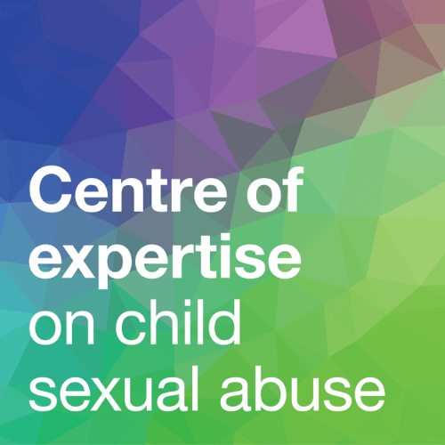
- Centre of Expertise on Child Sexual Abuse: This national organisation provides a range of FREE webinar e-learning opportunities as well as linked resources and tools: eLearning | CSA Centre

- Neurodiversity Support Pathway
Neurodiversity support pathway - NHS Cheshire and Merseyside
Includes information for families of children and young people who may be neurodivergent, which is useful for professionals supporting these families.
Includes information around assessment pathways and right to choose but prioritises understanding and addressing needs. Provides information on resources, strategies and services to support all areas of children’s needs.
Includes a searchable database of all resources and services.

- ADHD Resources
ADHD Resources: Cheshire and Wirral Partnership NHS Foundation Trust
A number of short videos around various aspects of ADHD which is useful for both professionals and families.

- Cheshire East SEND and Inclusion Training SEND and inclusion training
Includes training offers for: Children and young people, Parents and carers, Schools and settings
The SEND Partnership Workforce.


- In Our Place: 3 FREE COURSES using the SOLIHULL APPROACH, supports mental wellbeing in parents, children and schools, older adults and high stress work places through an evidence based model in training, on line courses and resources:
Online courses for emotional health and wellbeing (inourplace.co.uk)
*Other FREE Learning Resources*

- The Police North West Regional Organised Crime Unit monthly SWAY newsletter: NWROCU - News May 2025



- As part of the Cheshire East Healthy Young Minds commission Visyon and Just Drop In are providing specialist (Solihull Approach) training for any professional working with children and young people in Cheshire East to access. There are 3 courses available: Understanding Attachment, Understanding brain development and Understanding trauma.


- The Government offers FREE online PREVENT training, to cover for instance, extremist behaviours with vulnerability of autism. For LOTS more information and resources, please visit: Regional Prevent education coordinators - GOV.UK.

And finally….
If you would like to see any multi-agency practice topics to support shared learning opportunities adding to our training programme, or you know of a great resource or service that you’d like to widely share, please contact us at: cescptraining@cheshireeast.gov.uk

CESCP TRAINING PROGRAMME MISSION STATEMENT:
April 2025 - March 2026
Our mission is to foster a safe and supportive environment for children by providing comprehensive safeguarding training. We aim to empower professionals and community members with the knowledge, skills, and confidence to identify, prevent, and respond to safeguarding concerns effectively. Through collaborative partnerships, we strive to promote a culture of vigilance, respect, and protection, ensuring the well-being and safety of every child in our area.

