The Local Authority Directors of Public Health in Cheshire and Merseyside, alongside Public Health England and NHS England, have chosen Suicide Prevention as a key priority for collective action across the region.
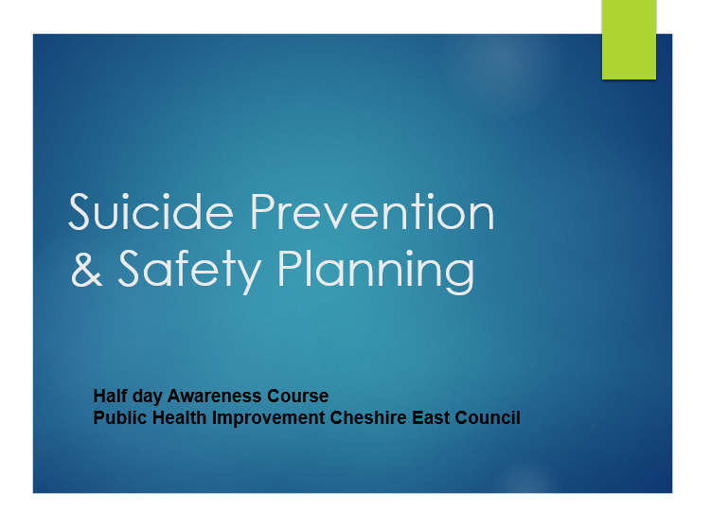
This course is a FREE online, half-day session for Cheshire East Statutory and VCSF Professionals.
Cheshire East Colleagues please book your place using the Learning Lounge
Scheduled dates:
Friday 23rd January 9.30am – 2.30pm – external partners booking form
Friday 13th March 9.30am - 2.30pm - external partners booking form
Friday 8th May 9.30am - 2.30pm - external partners booking form

Pre – learning: Essential to complete the 20-minute e-learning basic suicide prevention training: 20 minute suicide awareness training (zerosuicidealliance.com)

Resource booklets:
Suicide Risk Guidance for Professionals
self harm suicide risk guidance CEC

Reasonable adjustments please contact lori.hawthorn@cheshireeast.gov.uk
It is essential for learners to have cameras on and participation to achieve your certificate.

