
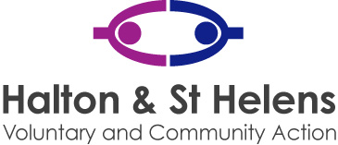

17 November 2025

Dear Applicant

Thank you for the interest you have shown in the Healthy and Home job vacancies .

You will need the:
- Job description and Person Specification – this will be used to shortlist for interview
- Application and Equal Opportunities Form

Please return your application by midday on 8th December 2025. Interviews date to be confirmed.
Please note that we will contact the successful candidates by phone so please make sure that you have included a daytime telephone number that we can contact you on.

CVs are not required. Please complete the application form, fully addressing the person specification as this will be used in the shortlisting process to select candidates for interview.

Yours sincerely

Yours sincerely,
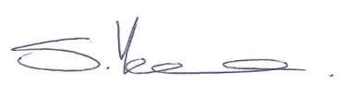
Sally Yeoman
Chief Executive Officer


Halton Office:
Halton & St Helens VCA and Volunteer Centre St Halton
St Maries, Lugsdale Road, Widnes, WA8 6DB
Tel: 01744 457100 Fax: 01744 457101
E: sthelens@haltonsthelensvca.org.uk www.haltonsthelensvca.org.uk

Registered in England & Wales as a Registered Charity No. 1106001. Company Limited by Guarantee No. 2539153

