.
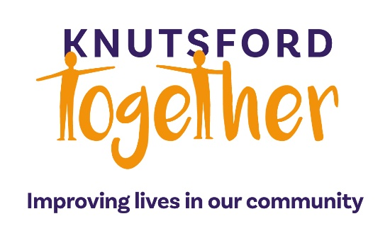
Deputy Chief Officer
Knutsford, Cheshire c£30,000 pa
If you really want to change people’s lives, this could be the opportunity for you. Knutsford Together was founded in 2022 and has been helping local residents to access the services and benefits that help them to resolve the problems that impact their lives. We help adults including those who face loneliness, physical and mental ill health, bereavement and addiction. We run a weekly “talking cafe”, wellbeing walk and, uniquely, visit clients in their own homes to allow them to share their concerns with us.
The Role
We’re looking for an exceptional candidate to take on this key role. You’ll need a strong knowledge of the welfare sector, excellent interpersonal skills and a flexible approach to problem solving, but most of all you’ll be driven by the desire to help people and want to play a key part in meeting their needs by spending time with them, both through group activities and on a one-to-one basis.
Key responsibilities
- To work closely with partners, stakeholders and agencies
- To manage and develop our network of volunteer befrienders
- Reporting to our Chief Officer, you will manage your own client caseload
Person specification
Person centred and experienced in dealing with people facing multiple challenges. having a caring and resilient personality. Knowledge of the welfare/benefits landscape is desirable. Excellent communication skills are more important than educational qualifications. You must be a confident Microsoft Office user. Access to private transport is essential. We will require references and an enhanced DBS certificate, arranged at our expense.
The rewards include a generous salary, expenses, five weeks’ holiday and working in a small friendly organisation.
LOCATION: Knutsford, Cheshire
Next step: Please email your CV and a covering letter about why you are the ideal candidate for this role to help@knutsfordtogether.org.uk.
Closing date 18th April 2025

