Volunteer Managers User Guide

Contents

Logging In

Opportunity Submission Form

Active Opportunities

Organisation Profile

Logging In

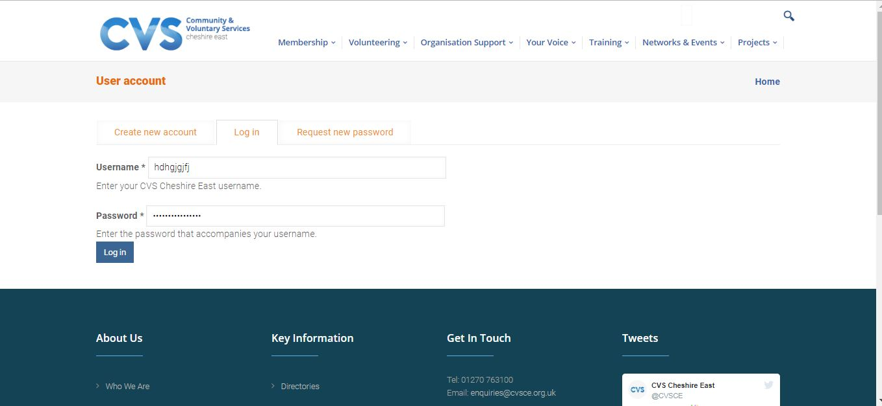

To log in to your account first navigate to https://www.cvsce.org.uk/user then enter your username and password in the boxes provided and click the log in button. (as shown above)

Opportunity Submission Form

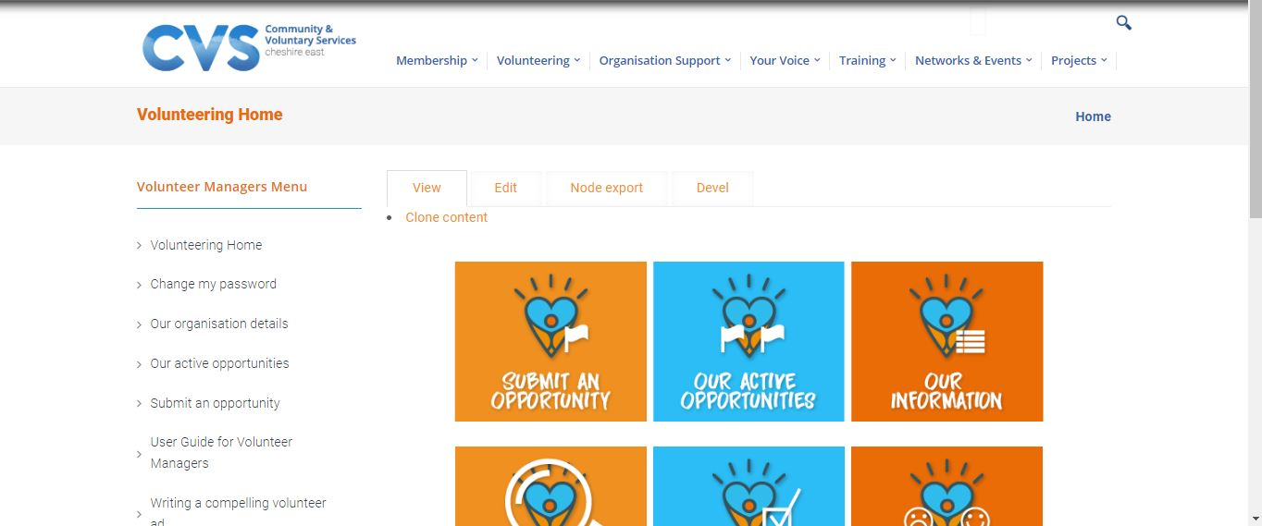

First login to your account and navigate to Submit an Opportunity. (As shown above)

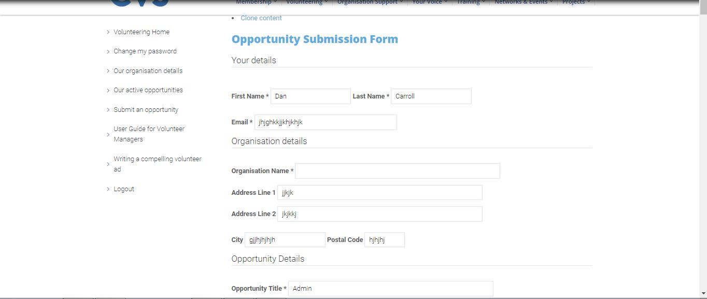

Begin the Opportunity Submission Form by providing your details and the name and address of your organisation. If your address details are amended here then they will also be amended in the database. (As shown above)

Then provide details of the opportunity such as title, address, days and times for the opportunity.

Select the volunteer commitment and provide a short description of your opportunity maximum of 30 words. Then provide a role description keeping it clear and simple using bullet points. Then select what groups/services within the community you want to help.

Then provide details of skills and qualifications required for the opportunity specify the application process and if a DBS check is required for the role.

Then answer questions on arrangements specifying gender or age restrictions, if you pay expenses, what support is available for the volunteer, if you have disabled access and if your insurance covers volunteers.

Then specify what training is available for the volunteer, if the opportunity is open to ex-offenders or ex-drug users and those in rehabilitation. Then select the type of activity (maximum of 5) and the opportunity locations.

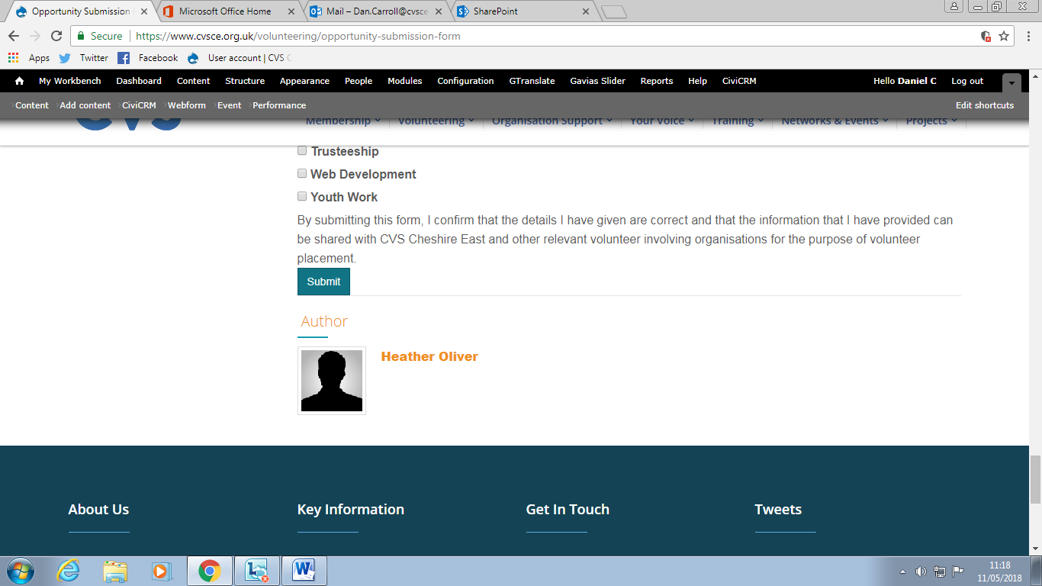

Then select Submit button (As shown above)

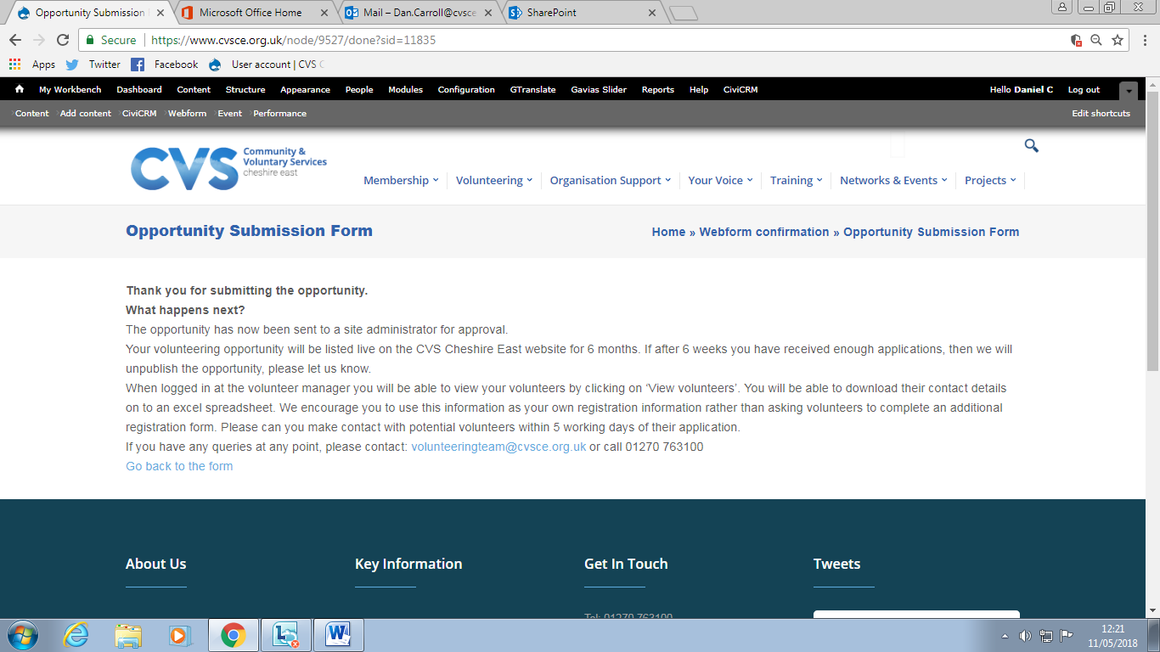

The opportunity will then be sent to a site administrator for approval. Your volunteering opportunity will be listed live on the CVS Cheshire East website for 6 months. If after 6 weeks you have received enough applications, then we will un publish the opportunity, please let us know. When logged in at the volunteer manager you will be able to view your volunteers by clicking on ‘View volunteers’. You will be able to download their contact details on to an excel spreadsheet. We encourage you to use this information as your own registration information rather than asking volunteers to complete an additional registration form. Please can you make contact with potential volunteers within 5 working days of their application. (As shown above)

Active Opportunities

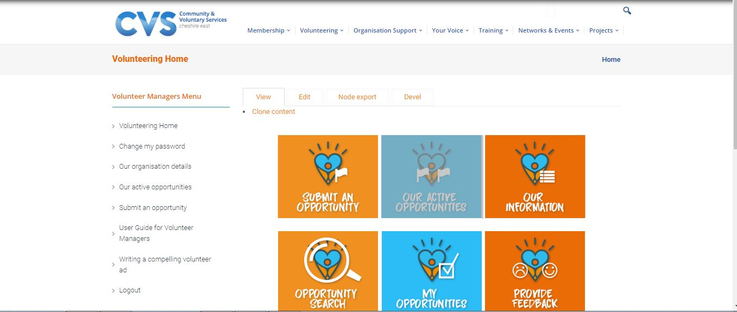

You can view your organisations active opportunities by selecting Our Active Opportunities. (As shown above)

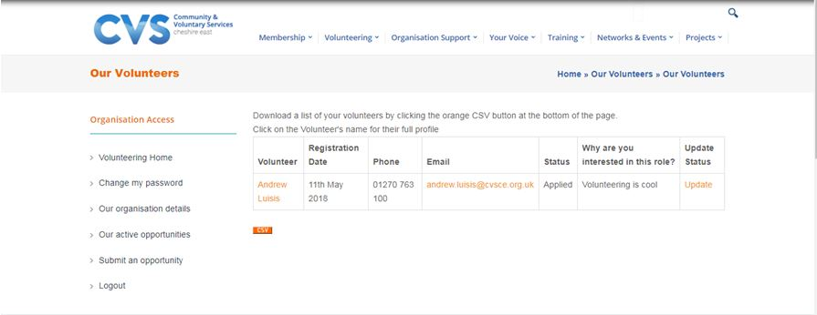

Your list of volunteers will then display under our active opportunities. (As shown above)

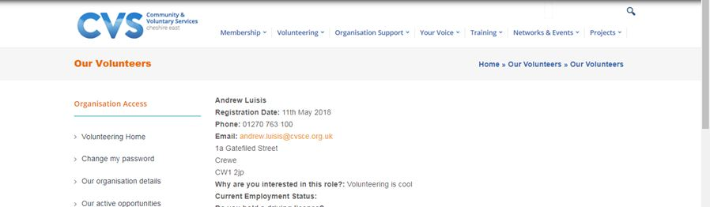

You can then view the Volunteers profile by clicking the volunteer’s name from the list displayed previously in our active opportunities. (As shown above)

Organisation Profile

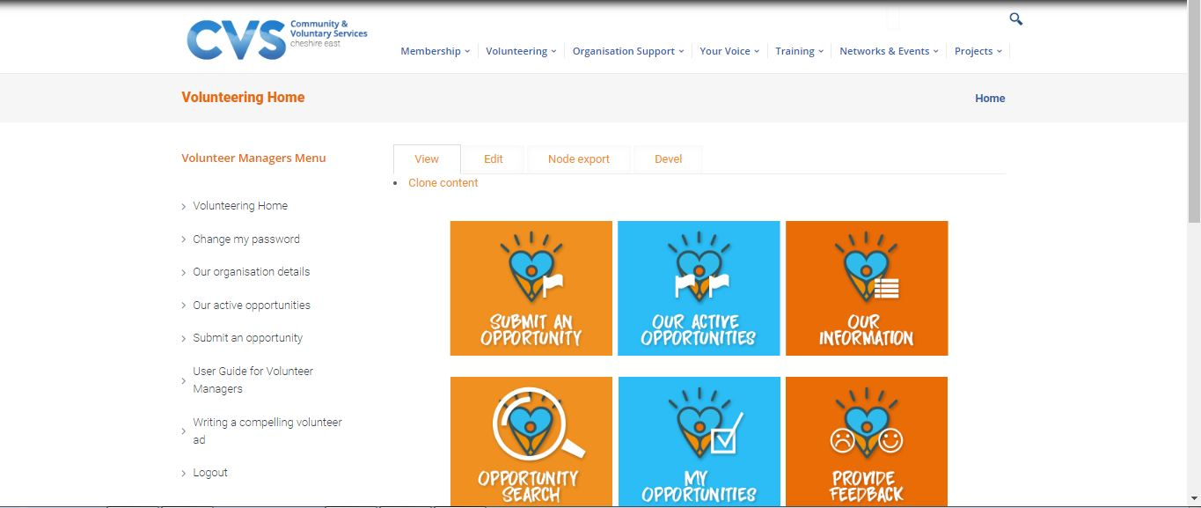

You can access your organisation profile by selecting Our organisation details or Our Information. (As shown above)

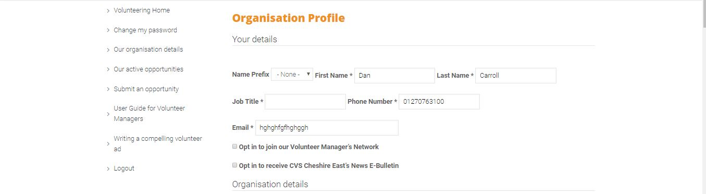

Here you can amend the personal and contact details of your organisation. You can also opt in to the Volunteer Manager’s Network or opt in to receive the CVS Cheshire East news E-Bulletin. You add you organisations logo by choosing a file to upload. (As shown above)

You can also provide an address for your organisation along with a brief description of your organisation and the services that it provides. Also you may select from the options available your organisations interests and the locations where you offer support.

You can then tell us if your organisation is a member of CVS Cheshire East and able to access our premium volunteer recruitment service. You can also tell us if your organisation is committed to equality of access to high quality opportunities without discrimination and how you heard about CVS Cheshire East. You are also asked if you agree to your organisation details being passed onto potential volunteers and also to your organisation and opportunities being included in a directory of volunteering opportunities and other volunteering promotions that CVS Cheshire East may be organising. You are also given the option to add a second contact person. Then click the Submit button.

If you do have any problems or issues with this service please don’t hesitate to contact us directly and we’ll be happy to help. Tel: 01270 763 100 Email: enquiries@cvsce.org.uk

