Sample
DBS Risk Assessment
[Organisation Name] is committed to offering fair recruitment and equal opportunities for all staff, volunteers and trustees regardless of race, gender, religion, sexual orientation, responsibilities for dependants, age, physical/mental disability or offending background.

[Organisation Name] actively promotes equality of opportunity for all with the right mix of talent, skills and potential and welcome applications from a wide range of candidates, including those with criminal records. Candidates are selected for interview based on their skills, qualifications and experience.

[Organisation Name] is also responsible for ensuring safe recruitment methods for all individuals to protect and safeguard all applicants and service users, therefore the following Risk Assessment will be completed to assess whether a DBS check should be completed.

Name of Applicant: ...........................................................................................................

Regulated Activity (See flowcharts below)

Is the volunteer in ‘Regulated’ Activity? Yes ¨ No ¨ If ‘yes’, an enhanced DBS with Barred list check is required.

Is the volunteer not in ‘Regulated’ Activity? Yes ¨ No ¨ If ‘no’, an enhanced DBS without a Barred list check may be obtained
Areas to Consider | Comments
Will the volunteer role include supporting children / young people (under 18 years old)?
Will the volunteer role include supporting Adults at Risk?
How frequently will the indivdual be volunteering?
What motivated the individual to volunteer?
Does the volunteer carry out a similar role with another organisation (or done so in the past)?
Can the volunteer provide at least one reference from someone other than a family member, including a senior person at the employment or voluntary service named above?
What do we already know about the volunteer?
Has the volunteer’s identity been verified?
Has the volunteer have a DBS check carried out elsewhere in the past? Can they share it?
If yes - Is the volunteer signed up to the update service?
Has the volunteer disclosed any information about a criminal conviction / caution relevant to the role in which they are applying?
Is the organisation aware of any reason to believe the volunteer may not be suitable for the role?
Definition of an Adult at risk
An adult at risk is a person aged 18 or over; who:
- has needs for care and support (whether or not the local authority is meeting any of those needs), and
- is experiencing, or is at risk of, abuse or neglect, and
- as a result of those needs is unable to protect himself or herself against the abuse or neglect or the risk of it.
This may include a person who:
- is an older person who is frail due to ill health, physical disability or cognitive impairment;
- has a learning disability;
- has a physical disability and/or a sensory impairment /or communication difficulty i.e. autism
- has mental health needs including dementia or a personality disorder;
- has a long-term illness/condition;
- misuses substances or alcohol;
- lacks capacity to make specific decisions to make particular decisions

Regulated Activity relating to children and young people
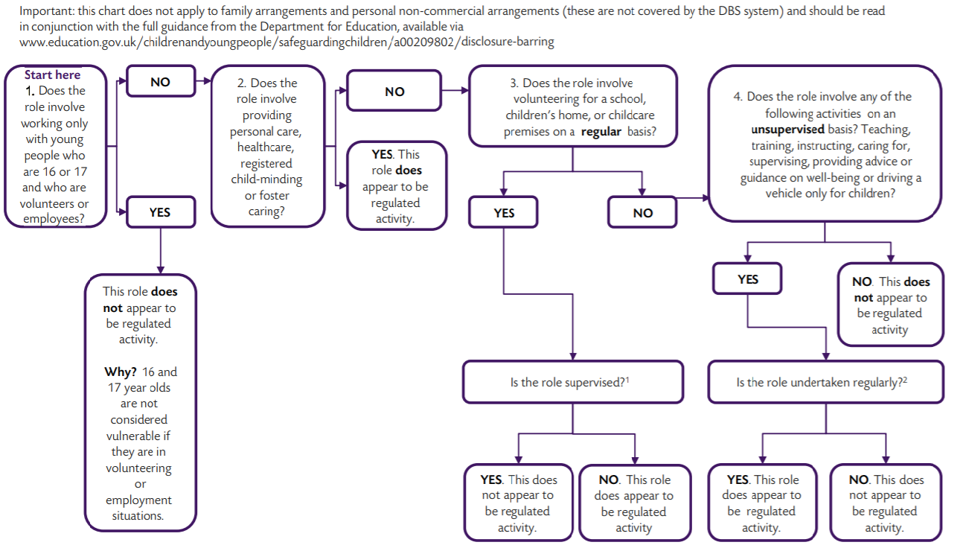
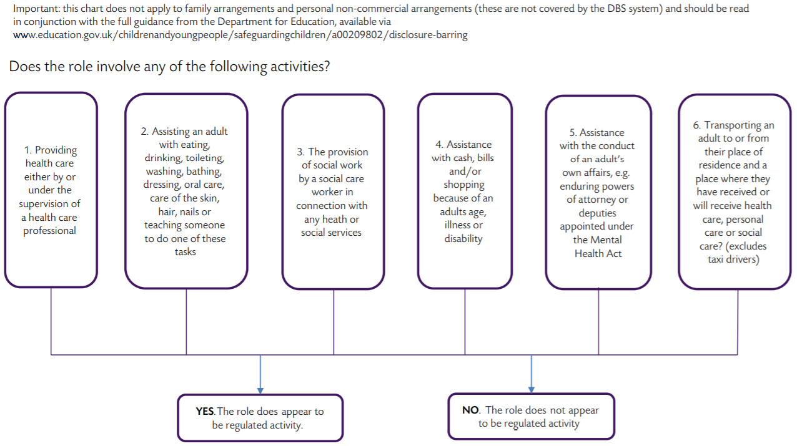
Regulated Activity relating to adults

