European Update for Cheshire and Warrington Voluntary, Community, and Social Enterprise Sector 16th September 2020

Headlines
ERDF commits all of its Reserve Fund
New ESF Digital Divide call to support existing ESF Participants

Coronavirus Response Investment Initiative (CRII) - ERDF Reserve Fund
All of the £80m in the ERDF Reserve Fund is being distributed, as listed below. There might be some more money in the future, depending on exchange rate changes, underspend on existing projects, and the results of ongoing appraisals (some bids from 2019 are still in appraisal).
• £50m Reopening High Streets Safely Fund via Local Authorities, based on population
• £10m Kick Starting Tourism via Growth Hubs, based on PA3(SME) & tourism employment
- £20m Support for Enterprises via Growth Hubs, based on PA3(SME)

The High Street Fund provides £831k to Cheshire and Warrington (£340k to Cheshire East, £305k to Cheshire West and Chester, and £186k to Warrington).

For Cheshire and Warrington, £223,873 is for Tourism and £391,240 for general support for Small and Medium Sized Enterprises. Grants of between £1,000 and £5,000, no match needed.
https://candwgrowthhub.co.uk/covid-19grantsbusrates/
http://www.871candwep.co.uk/cheshire-warrington-news/20-million-in-new-grants-to-boost-recovery-of-small-businesses/

CRII - ESF Reserve Fund
DWP has taken a different (and slower) approach. After stopping calls in March (when CRII was announced), calls were restarted in August, with the intention of committing the remaining approximately £290m by the end of September. To date, there have only been calls for under £16m, mainly for Cornwall.

There has also been what could be the first of a more specifically Covid call. This is for £5m and is England wide (apart from London which will have a similar £5m call shortly). It is to tackle digital inclusion (which has been more apparent with Covid), applicants can bid for funding to support existing ESF Participants with the loan of a digital device (eg laptop/tablet) plus a dongle for three months internet access and delivery and set up costs. Roughly £500 per head. No match is needed, as this is a short term project and fits with CRII flexibility (like the three ERDF Funds above).

It uses Simplification through Lump Sum (available for 2014-20, but little used so far in England). This means that the contract is to deliver the agreed number of devices for the agreed price. If this is done, the payment is made - no need for receipts, bus tickets etc. If the agreed number is not delivered, then no grant is paid. Deadline end September, but bids processed as soon as they arrive. Organisations working with ESF Participants can apply direct (so no need to apply through a Co-Finance Organisation like the Lottery or ESFA).

There has been considerable interest in this across the country. Although £5m has been allocated, it could be increased if there is more demand. Also, there could be more Covid announcements, and more calls - see link below (check open calls).
www.gov.uk/european-structural-investment-funds

ESIF Coronavirus Response Page
The ESIF Coronavirus Response Page is useful for existing ESF, ERDF and EAFRD Projects, with a Q&A for each fund (frequently updated), for example wet signatures, reprofiling and delays.
www.gov.uk/government/publications/european-structural-and-investment-funds-coronavirus-covid-19-response

Appraisals
Appraisals of both ESF and ERDF bids continue to be very slow. Following repeated questions from the third sector (and others), the DWP is now producing Management Information on the progress of the appraisals, which is helpful. Recently, with the change to Simplification of the ESF Technical Assistance (now paid automatically to the DWP with their claims for projects), the DWP has confirmed it will have the remaining £87m of the TA. It is appointing a further 62 ESF staff, five of which will be allocated to appraisals. Most should be in place by October, and will be undergoing induction and training.

Getting Brexit done
The UK left the EU at the end of January and is currently in the Transition Period until the end of December, which means that little has changed (other than our involvement in EU decision making). Negotiations have been underway but there seems to be little progress on the trade talks which need to be completed in October in order to be ratified across Europe. It is still not clear if we will crash out with no trade agreement, or if some (perhaps minimal) agreement will be achieved with our largest trading partner. Third Sector organisations will doubtless be preparing for any issues arising from January.

UK Shared Prosperity Fund
This fund is to replace the current ESF and ERDF monies (€13bn or about £11.7bn over seven years) which we would have received if we had stayed in the EU. Until recently, we had been told that there would be the standard (12 week) consultation on this substantial fund. Recently it seemed that this open consultation has been scrapped, with a letter of 19th June implying there had already been enough discussion, and the Fund would be part of the Comprehensive Spending Review this Autumn. The Performance sub committee (of the PMC-Growth Board) will now be holding a special meeting on 22nd September.

NCVO-ERSA have updated their UK-SPF Principles paper of 2018, which should be published by the end of September.

Meanwhile, there is a specific reference to UK-SPF in the press release for the Government’s “Internal Market Bill” now being discussed in Parliament.
www.gov.uk/government/news/uk-internal-market-bill-introduced-today
https://commonslibrary.parliament.uk/research-briefings/cbp-9003

Network for Europe
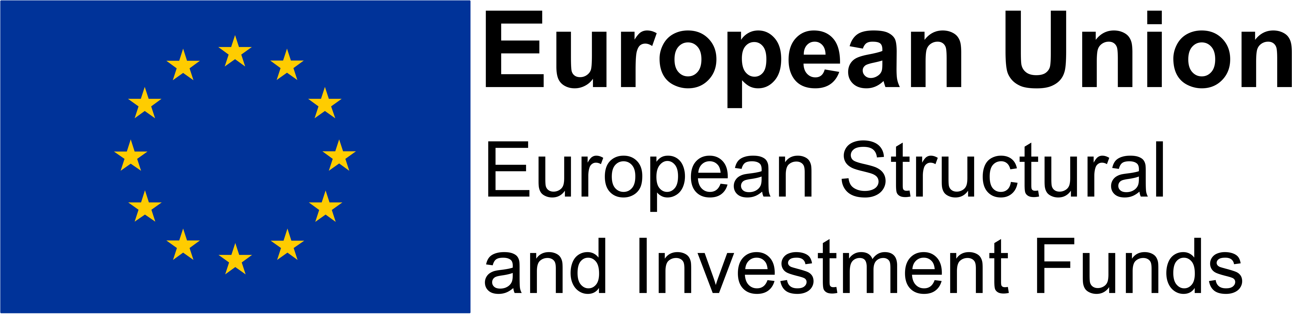
info@networkforeurope.eu

