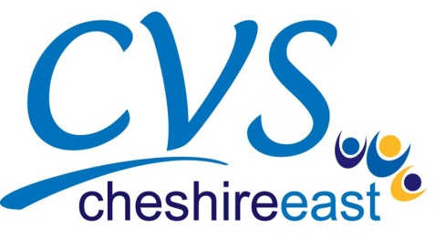

**Gift Aid declaration**

**Please treat**

□ The enclosed gift of £ ........................ as a Gift Aid donation; **OR**

□ All gifts of money that I make today and in the future as Gift Aid donations; **OR**

□ All gifts of money that I have made since 15th September 2009 and all future gifts of money that I

make from the date of this declaration as Gift Aid donations.

*Please tick the appropriate box*

*You must pay an amount of Income Tax and/or Capital Gains Tax for each tax year (6 April one year to 5 April the next) that is at least equal to the amount of tax that Community and Voluntary Services Cheshire East (CVSCE) will reclaim on your gifts for that tax year.*

**Donor’s details**

Forename(s) ................................................................. Surname ....................................................

Home address....................................................................................................................................

...........................................................................................................................................................

Postcode ............................. Date .....................................................................................

Signature ........................................................................................

**Please notify CVSCE if you:**

□ Want to cancel this declaration

□ Change your name or home address

□ No longer pay sufficient tax on your income and/or capital gains.

**Tax claimed by CVSCE**

* CVSCE will reclaim 25p of tax on every £1 you give on or after 15 September 2009.
* The Government will pay to CVSCE an additional 3p on every £1 given between 15 September 2009 and 5 April 2011. This transitional relief for CVSCE does not affect your personal tax position.

If you pay Income Tax at the higher rate, you must include all your Gift Aid donations on your Self Assessment tax return if you want to receive the additional tax relief due to you.

